**LAB CYCLE – 4**

**PROGRAM NO : 01**

**Aim:**

**Write a program to print the Fibonacci series using recursion.**

**Source Code:**

**def fibonacci(n):**

**if n<=1:**

**return n**

**else:**

**return fibonacci(n-1)+fibonacci(n-2)**

**num=int(input("Enter the number of terms:"))**

**if num<0:**

**print("Please enter a positive integer")**

**else:**

**print("Fibonacci Series :")**

**for i in range(num):**

**print(fibonacci(i),end=" ")**

**Output:**

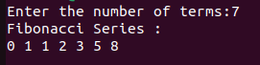

**________________________________________________________________________________**

**PROGRAM NO : 02**

**Aim:**

**Write the to implement a menu-driven calculator. Use separate functions for the different operations.**

**Source Code:**

**def addition(a,b):**

**return a+b**

**def subtraction(a,b):**

**return a-b**

**def multiplication(a,b):**

**return a*b**

**def division(a,b):**

**return a/b**

**a=int(input("Enter the first number:"))**

**b=int(input("Enter the second number:"))**

**while True:**

**print("1.Addition\n2.Subtraction\n3.Multiplication\n4.Division\n5.Exit")**

**c=input("Enter your choice:")**

**if c=='5':**

**break;**

**elif c=='1':**

**print(f"{a} + {b} = {addition(a,b)}\n")**

**elif c=='2':**

**print(f"{a} - {b} = {subtraction(a,b)}\n")**

**elif c=='3':**

**print(f"{a} * {b} = {multiplication(a,b)}\n")**

**elif c=='4':**

**print(f"{a} / {b} = {division(a,b)}\n")**

**else:**

**print("Invalid Choice!!\n")**

**Output:**

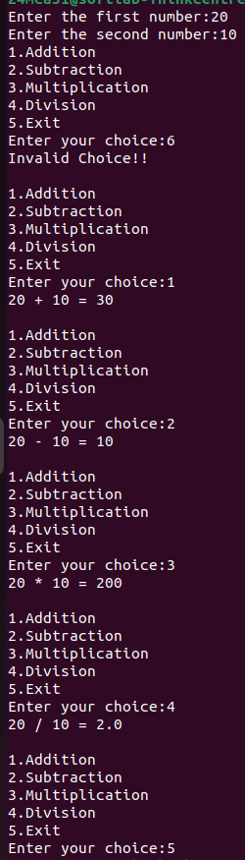

**________________________________________________________________________________**

**PROGRAM NO : 03**

**Aim:**

**Write a program to print the nth prime number. [Use function to check whether a number is prime or not]**

**Source Code:**

**def is_prime(num):**

**if num<=1:**

**return False**

**for i in range(2,int(num**0.5)+1):**

**if num%i==0:**

**return False;**

**return True**

**def nth_prime(n):**

**count=0**

**num=2**

**while True:**

**if is_prime(num):**

**count+=1**

**if count+1==n:**

**return num**

**num+=1**

**n=int(input("Enter the value of n to find the nth prime number:"))**

**if n<=0:**

**print("Please enter a positive integer.")**

**else:**

**result=nth_prime(n)**

**print(f"The {n}th prime number is: {result}")**

**Output:**



**________________________________________________________________________________**

**PROGRAM NO : 04**

**Aim:**

**Write lambda functions to find the area of square, rectangle and triangle.**

**Source Code:**

**area_square=lambda side:side*side**

**area_rectangle=lambda length,breadth:length*breadth**

**area_triangle=lambda base,height:0.5*base*height**

**side=float(input("Enter the side of square in centimetres:"))**

**print("Area of Square :",area_square(side),"sq.cm")**

**length=float(input("Enter the length of rectangle in centimetres:"))**

**breadth=float(input("Enter the breadth of rectangle in centimetres:"))**

**print("Area of Rectangle :",area_rectangle(length,breadth),"sq.cm")**

**base=float(input("Enter the base of triangle in centimetres:"))**

**height=float(input("Enter the height of triangle in centimetres:"))**

**print("Area of Triangle :",area_triangle(base,height),"sq.cm")**

**Output:**

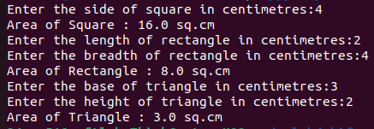

**________________________________________________________________________________**

**PROGRAM NO : 05**

**Aim:**

**Write a program to display powers of 2 using anonymous function. [ Hint use map and lambda function)**

**Source Code:**

**num = input("Enter a list of numbers separated by space: ")**

**n = num.split()**

**lst = []**

**for i in n:**

**lst.append(int(i.strip()))**

**powers_of_2 = list(map(lambda x: 2 ** x, lst))**

**print("Powers of 2:", powers_of_2)**

**Output:**



**________________________________________________________________________________**

**PROGRAM NO : 06**

**Aim:**

**Write a program to display multiples of 3 using anonymous function. [ Hint use filter and lambda function)**

**Source Code:**

**num = input("Enter a list of numbers separated by space: ")**

**n = num.split()**

**lst = [int(i.strip()) for i in n]**

**multiples_of_3 = list(filter(lambda x: x % 3 == 0, lst))**

**print("Multiples of 3:", multiples_of_3)**

**Output:**



**________________________________________________________________________________**

**PROGRAM NO : 07**

**Aim:**

**Write a program to sum the series 1/1! + 4/2! + 27/3! + ….. + nth term. [ Hint Use a function to find the factorial of a number].**

**Source Code:**

**def factorial(num):**

**if num==0 or num==1:**

**return 1**

**else:**

**result=1**

**for i in range(2,num+1):**

**result*=i**

**return result**

**def sum_series(n):**

**series_sum=0**

**for i in range(1,n+1):**

**term=(i**i)/factorial(i)**

**series_sum+=term**

**return series_sum**

**n=int(input("Enter a positive integer:"))**

**if n<0:**

**print("Please enter a positive integer.")**

**else:**

**result=sum_series(n)**

**print(f"The sum of the series 1/1! + 4/2! + 27/3! + .... upto {n} terms is: {result}")**

**Output:**

**________________________________________________________________________________**

**PROGRAM NO : 08**

**Aim:**

**Write a function called compare which takes two strings S1 and S2 and an integer n as arguments. The function should return True if the first n characters of both the strings are the same else the function should return False.**

**Source Code:**

**def compare(s1,s2,n):**

**if s1[:n]==s2[:n]:**

**return True**

**else:**

**return False**

**s1=input("Enter first String:")**

**s2=input("Enter second String:")**

**n=int(input("Enter an integer:"))**

**result=compare(s1,s2,n)**

**if result==True:**

**print(f"The first {n} characters of both the strings are same.")**

**else:**

**print(f"The first {n} characters of both the strings ar not same.")**

**Output:**

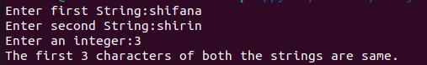

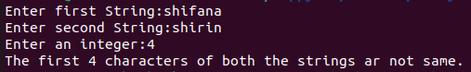

**________________________________________________________________________________**

**PROGRAM NO : 09**

**Aim:**

**Write a program to add variable length integer arguments passed to the function. [Also demo the use of docstrings]**

**Source Code:**

**'''program to add variable length integer arguments**

**passed to the function 'add' and also to demonstrate**

**the use of docstrings '''**

**def add(*args):**

**return sum(args)**

**n=int(input("Enter the number of elements:"))**

**l=[]**

**for i in range(n):**

**a=int(input("Enter a number:"))**

**l.append(a)**

**result=0**

**for i in l:**

**result=result+i**

**print("The sum is:", result)**

**Output:**

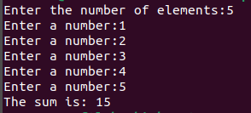

**________________________________________________________________________________**

**PROGRAM NO : 10**

**Aim:**

**Write a program using functions to implement these formulae for permutations and combinations. The Number of permutations of n objects taken r at a time: p(n, r) = n!/(n − r)!. The Number of combinations of n objects taken r at a time is: c(n, r) = n!/(r! ∗ (n − r)!)**

**Source Code:**

**ef factorial(n):**

**if n==0 or n==1:**

**return 1**

**else:**

**return n*factorial(n-1)**

**def permutation(n,r):**

**return factorial(n)/factorial(n-r)**

**def combination(n,r):**

**return factorial(n)/(factorial(r)*factorial(n-r))**

**n=int(input("Enter the value of n:"))**

**r=int(input("Enter the value of r:"))**

**print(f"The number of permutaions of {n} objects taken {r} at a time : p({n},{r}) = {n}!/({n}-{r})! = {permutation(n,r)}")**

**print(f"The number of Combinations of {n} objects taken {r} at a time : c({n},{r}) = {n}!/({r}! * ({n}-{r})!) = {combination(n,r)}")**

**Output:**



**________________________________________________________________________________**